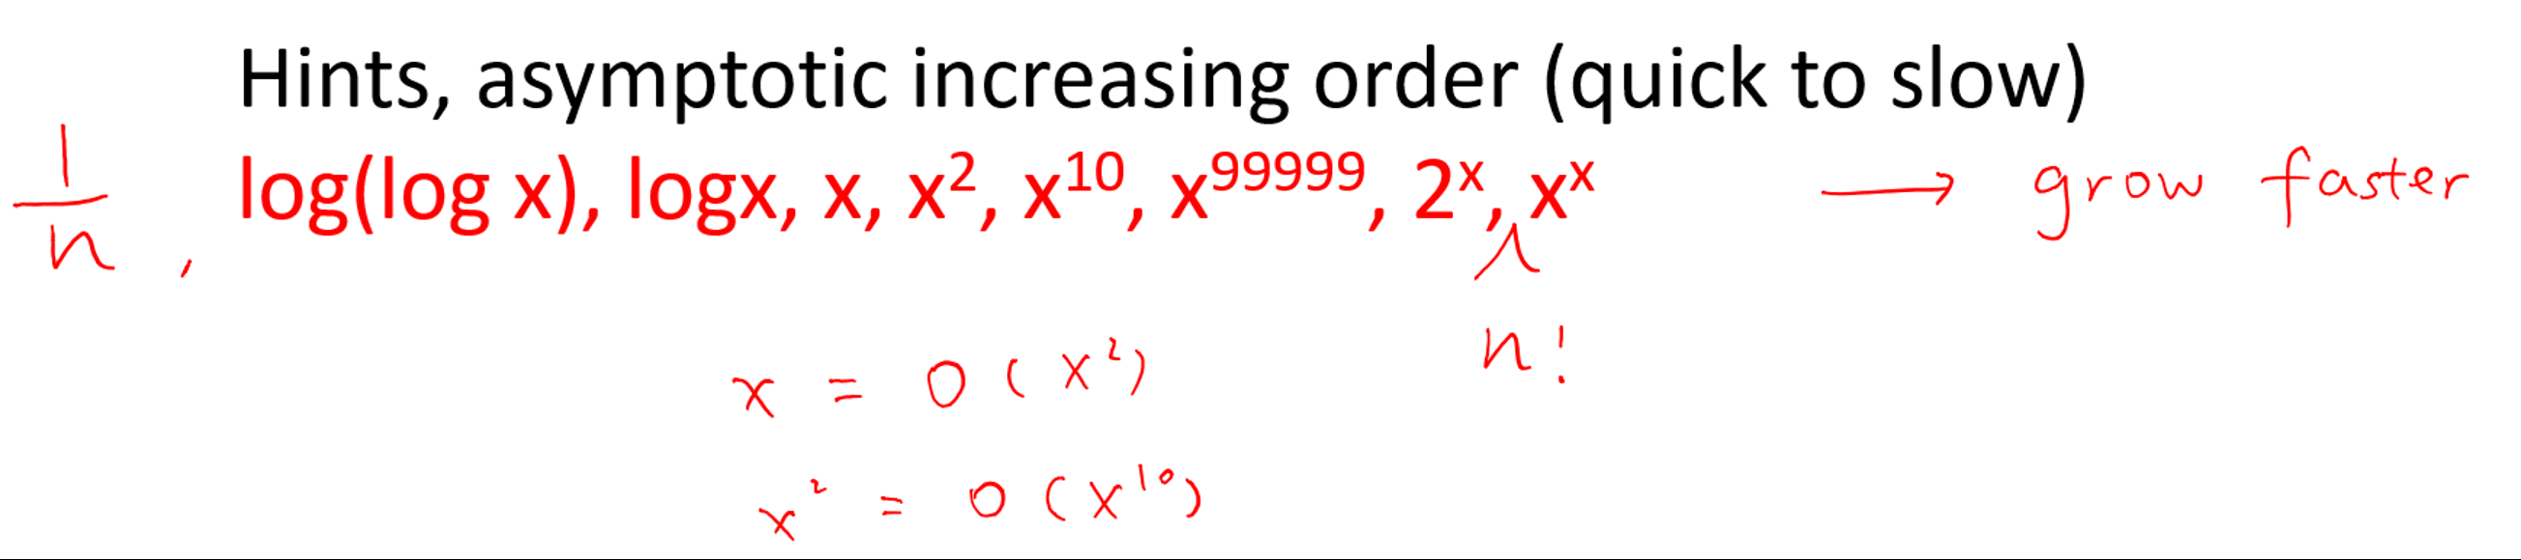C:\Users\ZHANGZ~1\AppData\Local\Temp\msohtmlclip1\02\clip_image001.png







in-place sort: if the sorted item occupy the same storage as the original one.

Out-of-space sort: if the sorting algorithm used extra space to do the sorting







f(n)

Increase



Priority Queue

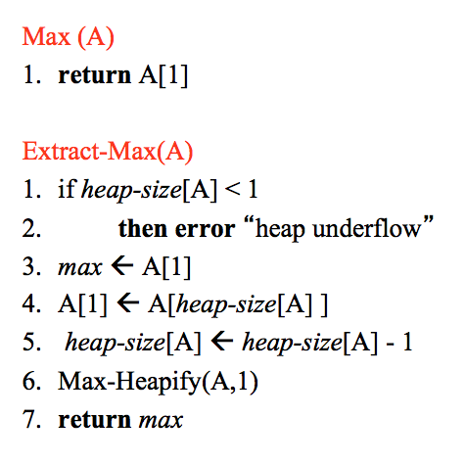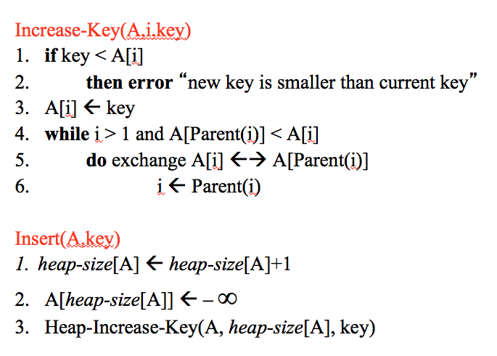

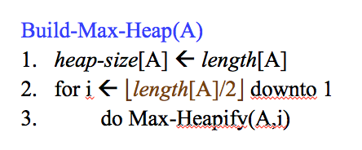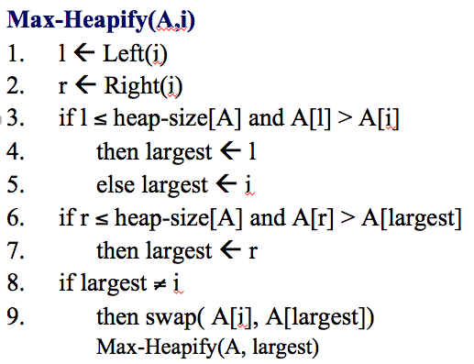

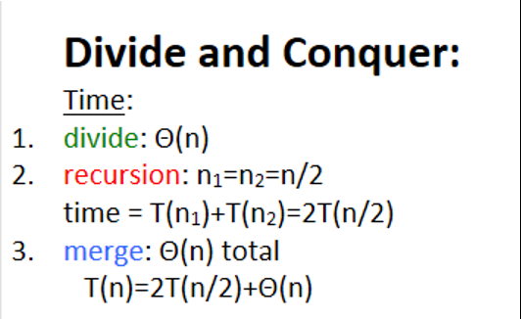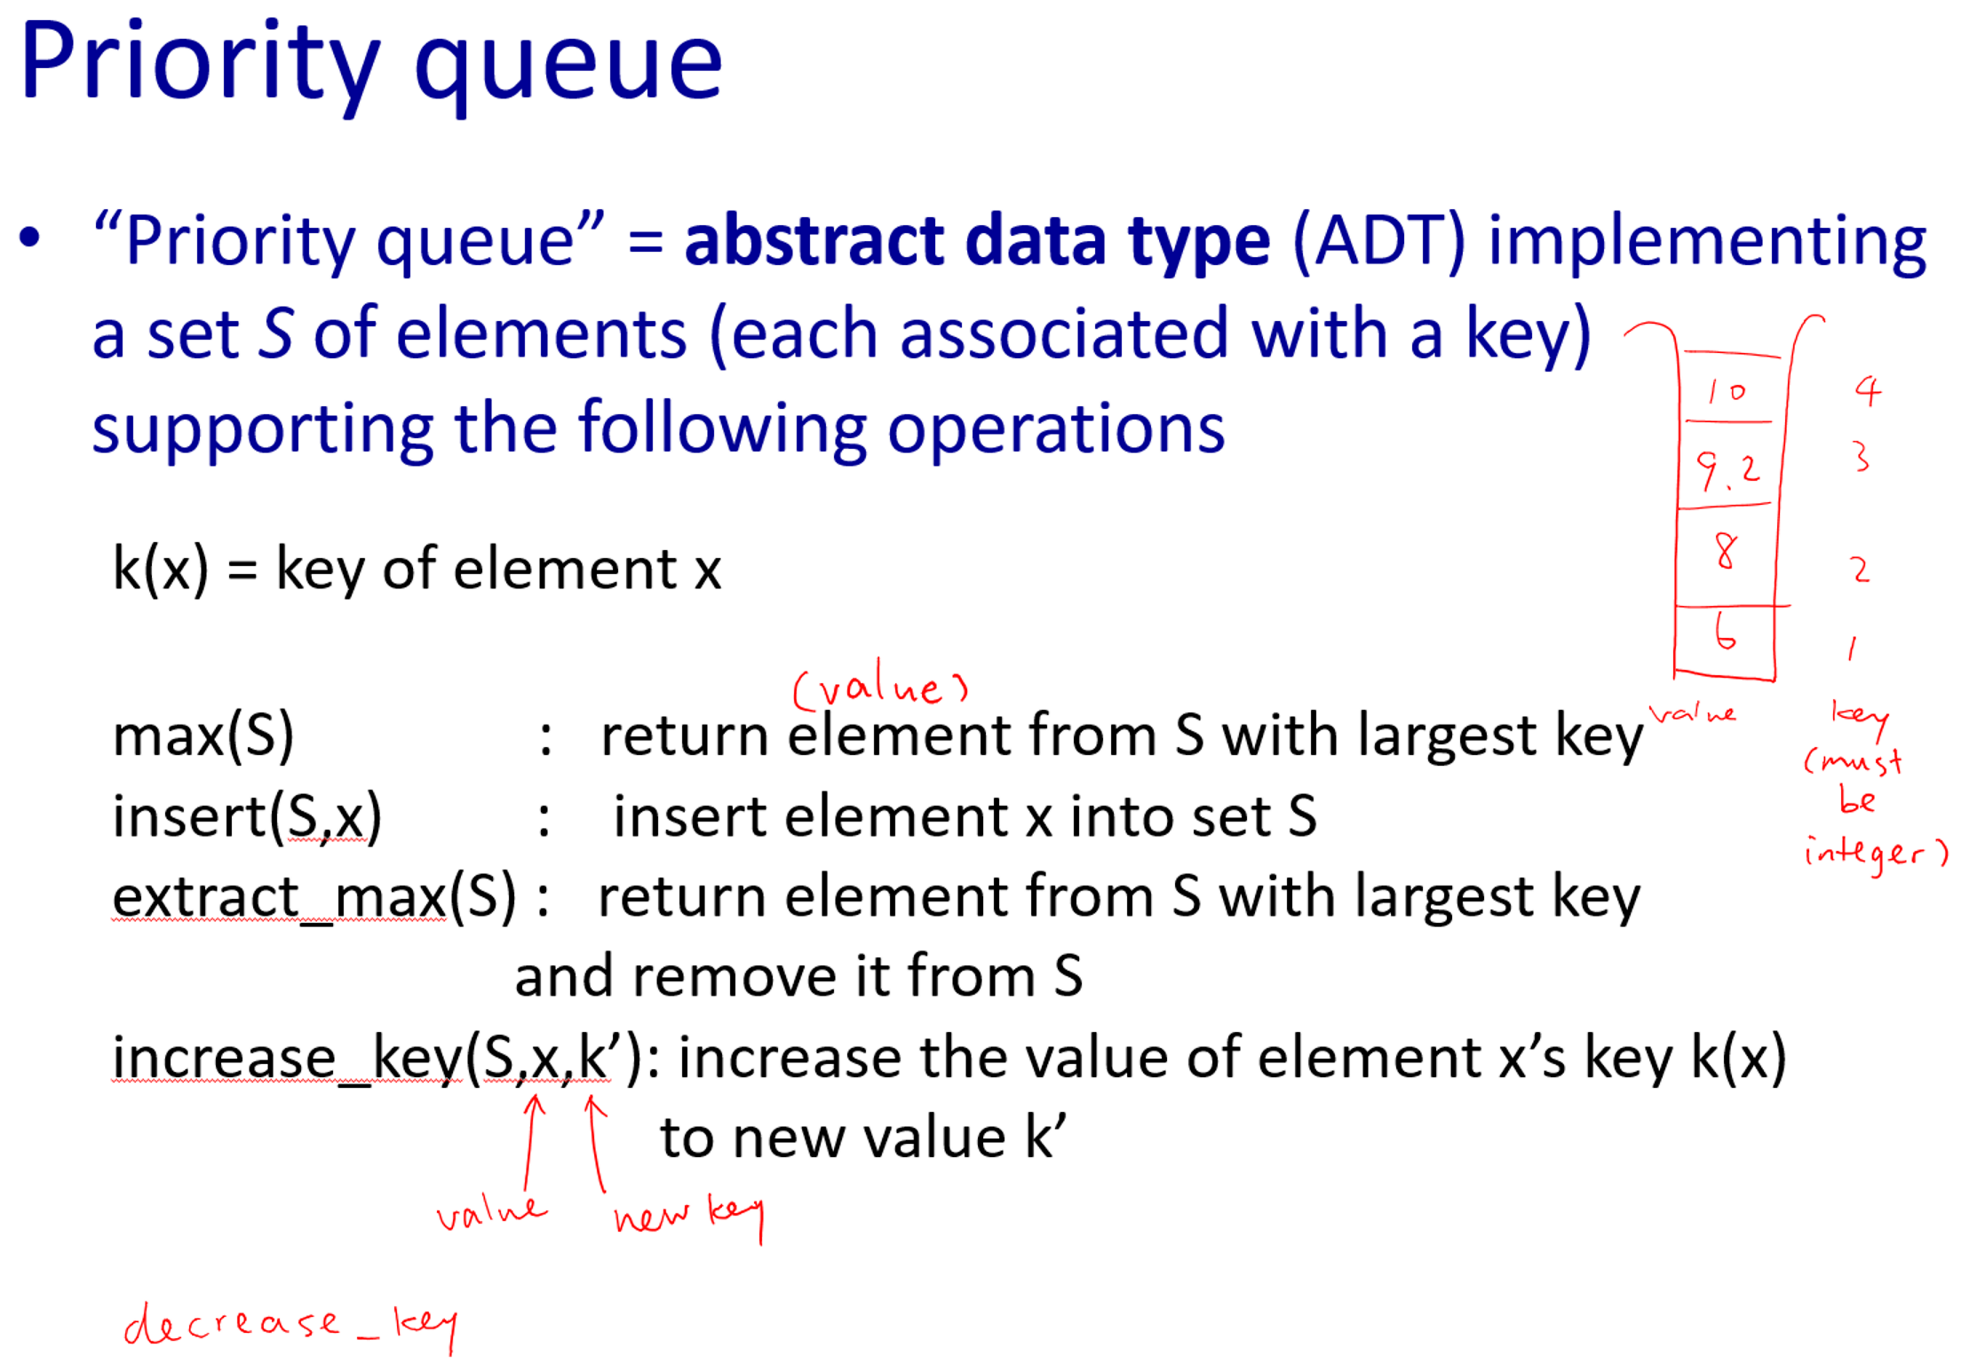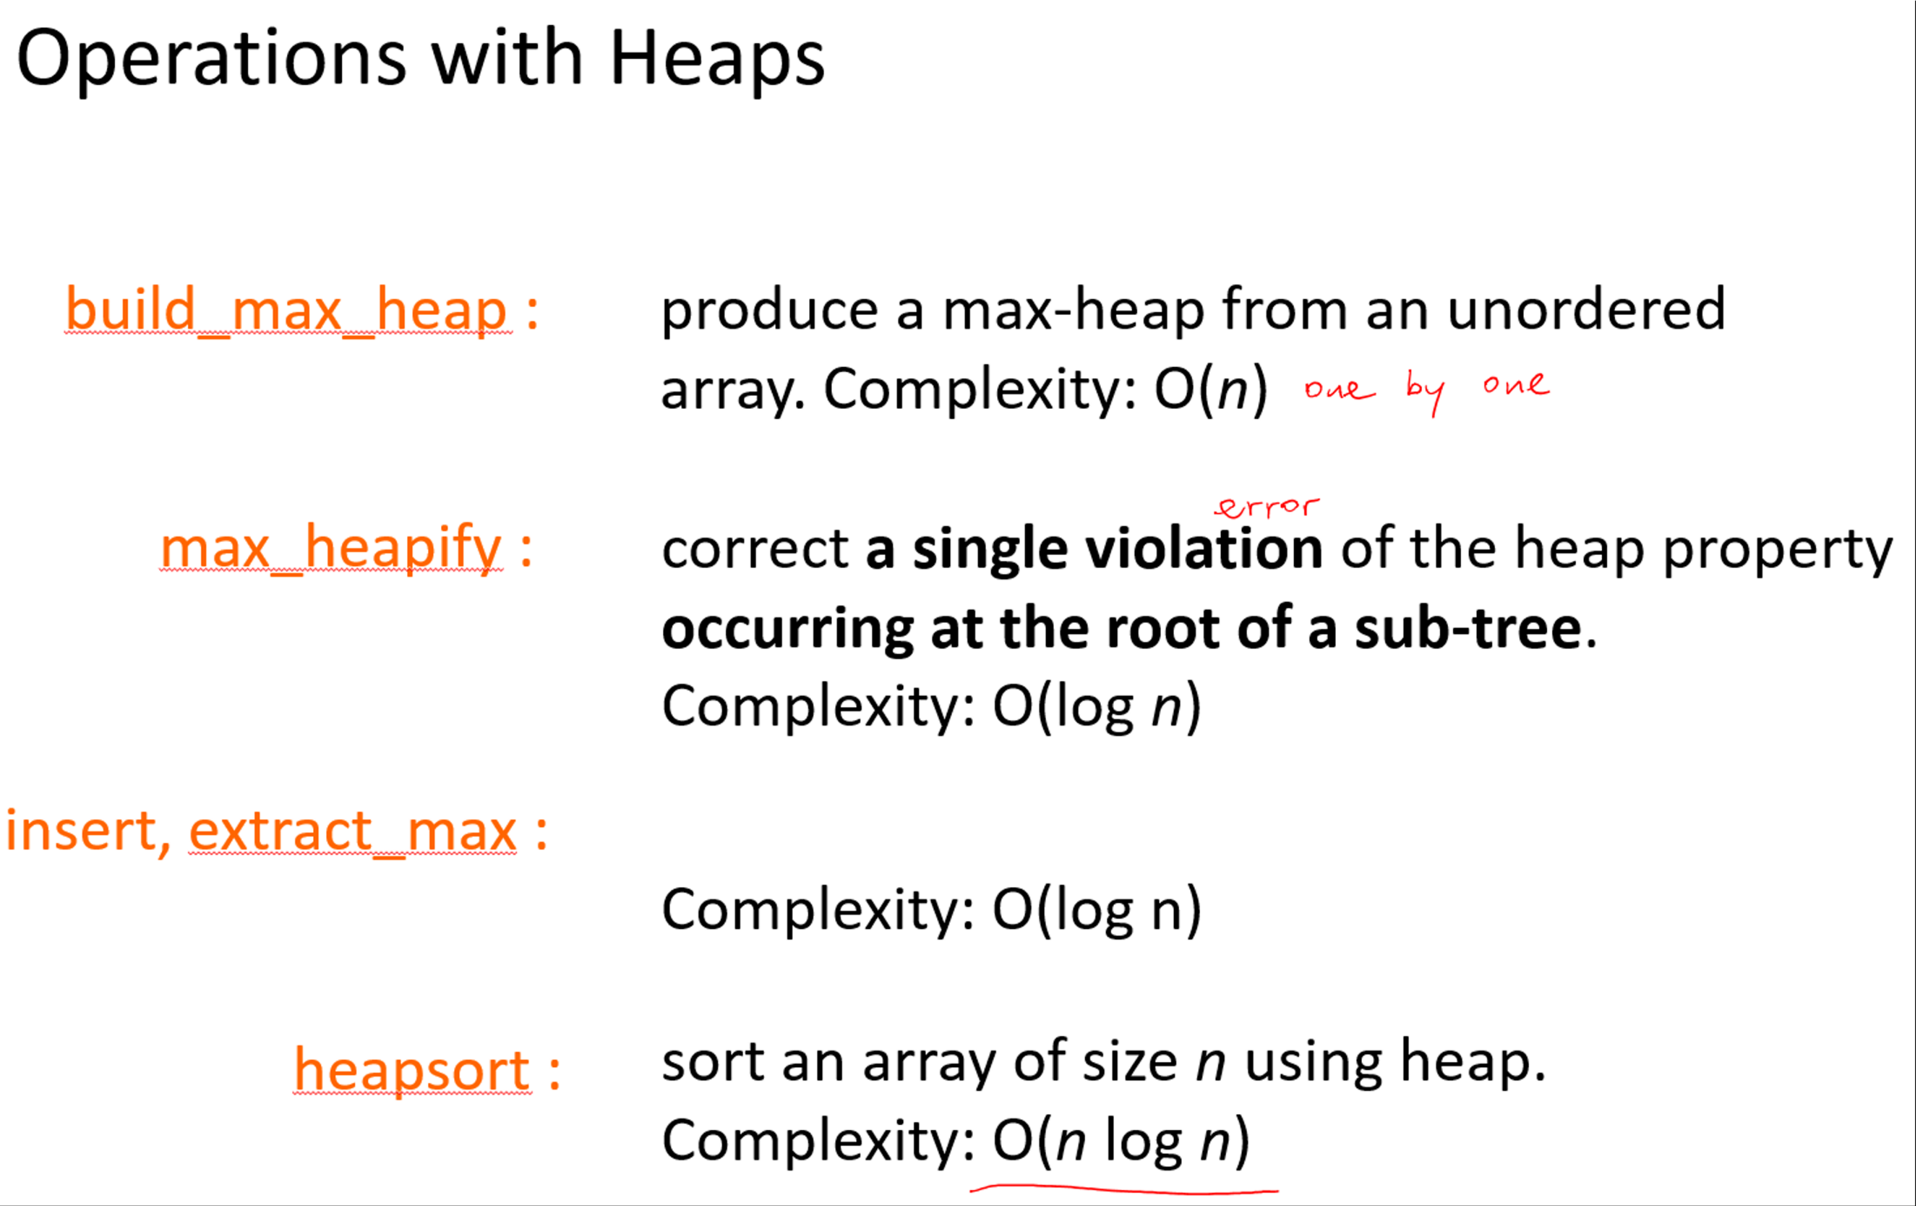

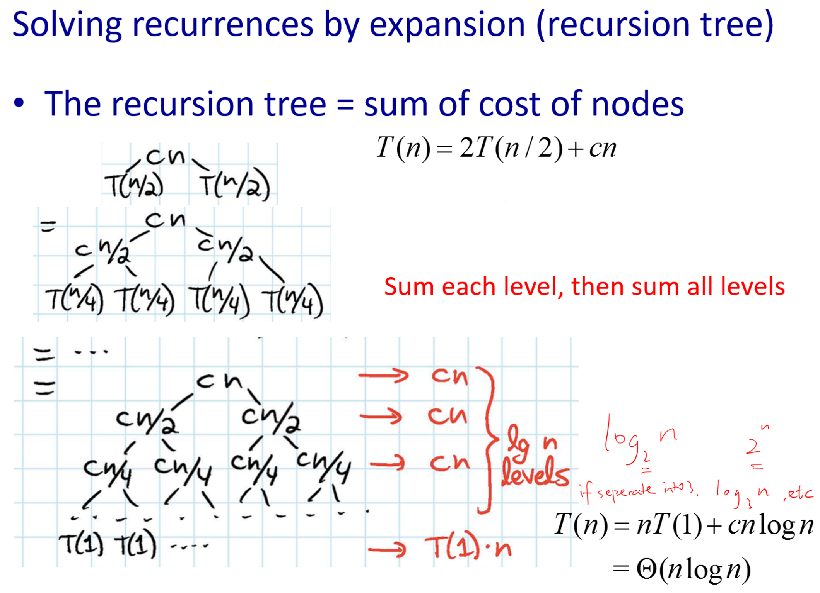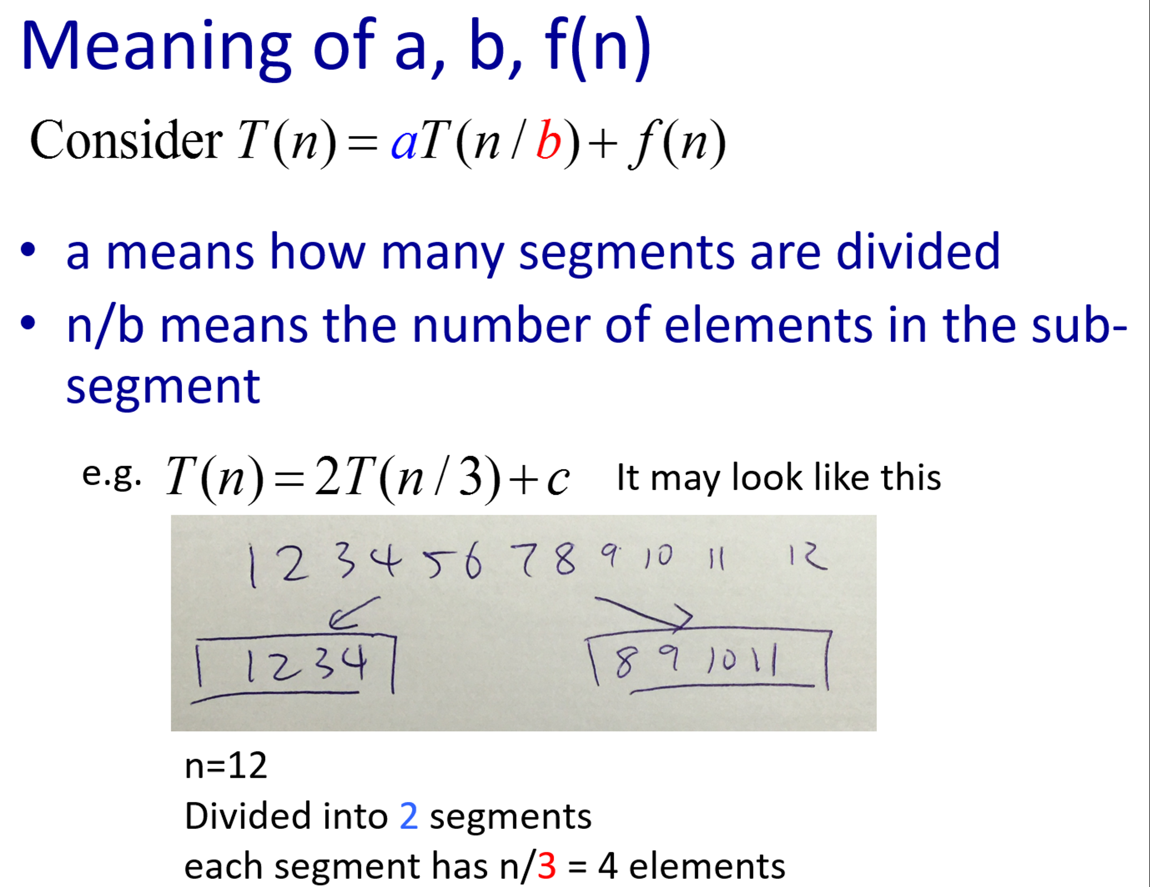

|  |  |
| --- | --- |
| **operation** | **Heap** |
| max(S) | Θ(1) |
| insert(S,x) | Θ(logn) |
| extract\_max(S) | Θ(logn) |
| increase\_key(S,x,k) | Θ(logn) |

